**CS 7075**

**ARTIFICIAL INTELLIGENCE & ROBOTICS**

**PROJECT REPORT**

**INSTRUCTOR**

**Dr. Waqas Majeed**

**Rohith Sundar Jonnalagadda Sai Veera Venkata Akshay Adabala**

KSU ID: 001093082 KSU ID: 001140226

**Ramani Potlapati**

KSU ID: 001125320

Comparative Analysis of Maze Path Planning Using Enhanced Sparse A* Algorithm with Obstacle Variations

**SUMMARY**

In our project, we aimed to enhance path planning in environments with obstacles of varying shapes and sizes by employing a combination of map segmentation and visibility graph-based approaches. Inspired by [1], who proposed decomposing map boundaries and obstacles into convex polygons for the application of a sparse A* algorithm, we adapted and expanded upon their methodology to improve efficiency and path quality. Our approach began with processing a map image to detect the map boundary and any internal obstacles. We used edge detection techniques, specifically the Canny edge detector, to identify significant edges within the image. Contour detection was then applied to extract the map boundary and obstacle contours. The largest external contour was identified as the map boundary, while internal contours were considered obstacles. To simplify the contours and reduce computational complexity, we approximated them using the Douglas-Peucker algorithm. This algorithm reduces the number of vertices in the contours while preserving their essential shape. We ensured the vertices of the polygons were sorted in a consistent clockwise order, which is crucial for accurate geometric representation and subsequent processing. We then classified each vertex of the polygons as convex or concave by analyzing the cross products of adjacent edges. This classification is important for understanding the geometric properties of the map and can influence pathfinding decisions.

To prepare the environment for efficient path planning, we decomposed the map boundary and obstacles into convex sub-polygons using constrained Delaunay triangulation. This process involved creating a triangulation that respects the original geometry of the map, including holes representing obstacles. By decomposing the environment into triangles, we created a simplified representation that is more suitable for computational analysis. With the environment represented as a set of convex sub-polygons, we constructed a visibility graph. This graph models the navigable space by connecting vertices that have a clear line of sight, avoiding intersections with obstacles. The visibility graph serves as the foundation for the A* pathfinding algorithm, allowing us to compute the shortest path between a user-defined start and goal point efficiently. We implemented the A* algorithm on the visibility graph to find the optimal path. The algorithm utilizes a heuristic based on the Euclidean distance to estimate the cost from the current node to the goal, enabling it to prioritize paths that are more likely to lead to the goal quickly. This approach significantly reduces computational complexity compared to traditional grid-based methods, as it limits the search space to relevant points in the environment. To further enhance the path, we applied Bezier curve smoothing. This process reduces sharp turns and creates a more natural and efficient route, which is particularly beneficial for applications like robotics and autonomous navigation, where smooth paths are preferable. We ensured that the smoothed path did not intersect any obstacles by performing collision detection using geometric operations with the obstacle polygons.

Our preprocessing-based method offers significant advantages, including reduced computational complexity and improved global optimality over traditional grid-based A* algorithms. By segmenting the map into convex sub-polygons and constructing a visibility graph, we limited the number of nodes and edges the algorithm needs to consider, leading to faster computations and more optimal paths. Our approach aligns with the findings of [1], which highlighted the efficiency of convex decomposition and node-based regionalization in improving the A* algorithm's performance regarding speed, path quality, and computational stability. By integrating image processing techniques, computational geometry, graph theory, and optimization algorithms, our project contributes to the development of efficient path planning methods in complex environments.

Our Contributions:

* Map Segmentation: We utilized image processing to detect and simplify the map boundary and obstacles, leading to a more efficient representation of the environment.
* Convex Decomposition: By decomposing the environment into convex sub-polygons (traingles), we reduced computational complexity and facilitated the construction of the visibility graph.
* Visibility Graph Construction: Our method accurately models navigable spaces by accounting for line-of-sight connections between key points, ensuring that only feasible paths are considered.
* Efficient Pathfinding with A* Algorithm: Implementing the A* algorithm on the visibility graph allowed us to find optimal paths more efficiently than traditional grid-based approaches.
* Path Smoothing with Bezier Curves: We enhanced path quality by smoothing the initial path, resulting in smoother trajectories suitable for real-world navigation applications.
* User Interaction: We also provided an interactive interface for users to select start and goal points, enhancing the usability and practicality of our method.

By combining these techniques, our project demonstrates a comprehensive approach to path planning in complex environments with irregular obstacles. The integration of these methods results in a system that is both efficient and effective, capable of producing high-quality paths suitable for various applications, such as robotics, autonomous vehicles, and spatial analysis.

**ROBOTICS PROBLEM DEFINITION**

The primary problem involves planning a collision-free, optimal path for a mobile robot navigating through mazes and maps filled with obstacles of various shapes and sizes. The robot must efficiently find a path from an initial position to a target position, avoiding these obstacles and passing through narrow pathways, all while adhering to constraints such as limited computational resources and real-time requirements. This problem becomes particularly challenging when the environment is complex, with densely packed or irregularly shaped obstacles, which require the robot to make precise and efficient movements. Efficient and reliable path planning in such environments is a critical issue in robotics, especially for applications like autonomous navigation, industrial automation, and unmanned aerial vehicles (UAVs). In these scenarios, the ability to navigate through dynamic or complex environments while minimizing path cost (e.g., time, distance, or energy) is crucial for both safety and operational efficiency. Furthermore, ensuring that the pathfinding algorithm is scalable to larger, more complex environments is essential for real-world deployment in sectors like logistics, surveillance, and search and rescue operations.

**AI AND ROBOTICS PROBLEMS ADDRESSED**

Path Planning: Our project focuses on path planning for mobile robots, particularly optimizing the process of finding obstacle-free routes in complex environments. The Sparse A* algorithm is used to improve pathfinding efficiency and path optimality.

**AI METHODS**

* Traditional A* Algorithm: Utilizes grid-based search with heuristics to find an optimal path but is computationally intensive in large environments.
* RRT (Rapidly-exploring Random Tree): Incrementally explores the configuration space using random sampling, suitable for high-dimensional spaces but may produce irregular paths.
* RRT* (Rapidly-exploring Random Tree*): Optimizes paths through a rewiring process, providing probabilistic completeness and asymptotic optimality.
* PRM (Probabilistic Roadmap): Builds a reusable graph of collision-free paths for efficient query-based navigation.
* Our Improved A* Algorithm: Enhances pathfinding efficiency and quality by combining map segmentation, visibility graphs, and path smoothing.

**MAPS**

Figure 1: Map 1

Figure 2: Map 2

**METHODOLOGY**

**Convex Decomposition of the Map**

1. Image Preprocessing

The input image is read from the specified file path where the color image is converted to grayscale, it is because grayscale images simplify the data and are sufficient for edge detection. For edge detection we used canny which detects edges by looking for areas of rapid intensity change, using gradient values. The thresholds (50 and 150) define the sensitivity. Contours are extracted from that where the full hierarchy of nested contours are calculated. Then contours are approximated where they it compresses horizontal, vertical, and diagonal segments, keeping only their end points.

2. Map Boundary Detection

The assumption is that the map boundary is the largest external contour. So, we have done hierarchy analysis where the hierarchy information is used to identify top-level contours (contours with no parent, indicated by a parent index of '-1'). For each top-level contour, the area is calculated and the contour with the maximum area among these is selected as the map boundary. Then the Douglas-Peucker algorithm is implemented to simplify the contour by reducing the number of vertices while retaining the overall shape which gives us a simplified contour with fewer points, that helps in reducing computational complexity in subsequent steps. Then we used a sorting algorithm to sort the vertices based on calculated angle to the centroid for each vertex, this ensures consistency in the representation of the polygon, which is crucial for accurate triangulation and visualization.

3. Obstacle Detection

The hierarchy data from previous process provides information about the nesting of contours that allows identification of obstacles within the map boundary by analyzing which contours are descendants of the map boundary contour. Then to identify obstacles a loop is applied through all contours where for each contour the descendant of the map boundary is checked by traversing up the hierarchy from the current contour to see if the map boundary is an ancestor. Then area filtering is applied which ignores contours with areas too close to the map boundary area (to avoid misidentifying the boundary as an obstacle) and duplicates by checking if the area is like previously identified obstacles. Then the obstacle contours are simplified using the same approximation method where the vertices of the obstacles are then sorted in clockwise order to get the correct orientation of the polygon for us to identify if the polygon is convex or concave. Then the duplicate vertices are removed by comparing distances between consecutive vertices and removing those within a certain threshold distance.

Figure 3: Vertices of map boundary and obstacles detected in Map 1

4. Vertex Convexity Classification

Then the determination of each vertex in the polygon if it is convex or concave is done by calculating the cross product of adjacent vertices.

5. Orientation Correction

Here we ensure the polygon's vertices are ordered correctly (clockwise or counterclockwise) for the triangulation algorithm using Shoelace Formula for calculating the signed area and determining polygon orientation. If the orientation does not meet the requirement (e.g., if they are convex), the order of vertices are reversed to make them concave.

6. Constrained Triangulation

To preparing data for triangulation we firstly assign a unique index to each vertex and store them in a list, then created segments (edges) by pairing indices of consecutive vertices, then organized the vertices and segments into a dictionary 'A' suitable for the 'triangle' library. Obstacles are treated as holes in the triangulation where for each hole, compute a point inside the obstacle and add these points to the 'holes' key in the dictionary 'A'. Then we used the 'triangle' library (a Python wrapper for the Triangle software) to perform constrained Delaunay triangulation where a dictionary 'B' containing the triangulated vertices and the indices forming each triangle are obtained. To extract sub-polygons, we retrieved the corresponding vertices for each set of triangle indices in 'B['triangles']' and stored these vertices as individual sub-polygons (triangles) in result we got a list of convex sub-polygons representing the decomposed map. This is done for decomposing the polygon into convex sub-polygons while respecting the original geometry.

Figure 4: Convex Decomposition of Map 1

7. Calculating and Visualizing Centroids and Edge Midpoints

For each sub-polygon(triangle), we computed the centroid using the moments obtained to draw the centroids as blue circles and the edge midpoints as green circles on the image.

Figure 5: Centroids and Edge Midpoints of sub-polygons

**Optimized A* Algorithm**

Building upon the initial processing of the map image to detect boundaries and obstacles and performing constrained triangulation to decompose the area into convex sub-polygons, we further extended the methodology to include path planning. This extension involves:

* Reading the Decomposed Sub-polygons
* Constructing a Visibility Graph
* Implementing the A* Pathfinding Algorithm
* Path Smoothing using Bezier Curves
* User Interaction for Start and Goal Selection
* Visualization and Analysis of the Path

1. Reading Decomposed Sub-polygons

To import the convex sub-polygons (triangles) generated from the earlier constrained triangulation step. These sub-polygons represent the navigable space and obstacles within the map. From the file 'sub_polygons.txt' containing the list of sub-polygons from previous process we parsed each line to extract the coordinates of the vertices. Parsing is done by splitting the string representations to retrieve numerical coordinate pairs to store the sub-polygons as lists of vertex tuples. The sub-polygons are used to reconstruct the obstacle geometry in the map. They are converted into Shapely 'Polygon' objects for geometric operations.

2. Constructing the Visibility Graph

We created a graph where nodes represent points (vertices) in the environment, and edges represent direct lines of sight between these points that are not obstructed by obstacles. This graph serves as the foundation for the A* pathfinding algorithm. Firstly, we extracted all unique vertices from the sub-polygons (obstacles) and added the start and end points provided by the user. Then we created a dictionary where each key is a point, and the value is a list of adjacent points (neighbors) with corresponding edge costs. Then we created a unified geometric representation of all obstacles using 'unary_union' from Shapely where we generated the edges of sub-polygons and checked if this line intersects any obstacle. If the line does not cross any obstacles, we calculated the distance (edge weight) using the Euclidean distance heuristic and added each point to the other's adjacency list in the graph. The graph is undirected, and edges are bidirectional so to avoid redundant calculations, only unique pairs are considered and ensured that the edges in the visibility graph represent unobstructed paths.

3. Implementing the A* Pathfinding Algorithm

To implement the A* pathfinding algorithm on the visibility graph, a custom 'Node' class is used to represent each point in the graph with attributes such as coordinates, costs ('g', 'h', 'f'), and a reference to the parent node for path reconstruction. The nodes are ordered in a priority queue based on their total cost ('f'). The algorithm calculates the heuristic cost ('h') as the Euclidean distance between two points. During execution, the algorithm initializes the open list (a priority queue) with the start node and iteratively processes the node with the lowest 'f' cost. For each node, it updates the costs and parent references of its neighbors if a lower-cost path is found, adding them to the open list. Nodes are moved to a closed set once processed. The search ends when the goal node is reached, reconstructing the path by tracing back through parent nodes. If no path is found, the algorithm returns 'None'. This approach ensures efficient and optimal pathfinding while avoiding obstacles. The path is reconstructed in reverse order by following the 'parent' references from the goal node back to the start node. The path is then reversed to present it from start to goal.

4. Path Analysis

To calculate the path length and variance, we computed the Euclidean distance between each pair of consecutive points in the path. These distances are summed to determine the total path length. The variance of the distances is then calculated to assess the uniformity of the path segments, with a lower variance indicating more consistent segment lengths. This analysis is useful for evaluating the smoothness and uniformity of the generated path, which may be critical for certain applications.

5. Visualization of the Initial Path

Then we overlayed the computed path onto the original image for visualization. It drew lines between consecutive points in the path and highlights the start and end points with distinct colored circles. The resulting image is displayed in a window with an appropriate title, such as "Initial Path," and remains visible until a key press closes the window. This process helps in visually assessing the accuracy and feasibility of the generated path.

6. Path Smoothing using Bezier Curves

Then we generated a smoother path for real-world navigation while ensuring obstacle avoidance. It converts path points into NumPy arrays, parameterizes the path with a 't' value from 0 to 1, and fits a Bezier curve using polynomial fitting, typically with a degree of at least 3. A finer parameter 't_smooth' is used to create high-resolution smoothed 'x' and 'y' coordinates. The smoothed path is checked for collisions by iterating through its segments and ensuring no path crosses any obstacle. If collisions are detected, the smoothing is halted, and the original path is returned. This process balances smoothness with feasibility, considering the degree of the polynomial and collision avoidance to maintain realistic and usable paths.

7. User Interaction for Start and Goal Selection

This process allows users to specify start and goal points either manually or interactively, improving usability. Users can choose between manual coordinate input or interactive selection. For manual input, the program prompts for integer coordinates and validates them. For interactive selection, the image is displayed`, and a mouse callback function captures clicks. On a left mouse button click, the point is recorded, and a circle is drawn at the location for visual feedback. Once two points are selected, the pathfinding proceeds. Error handling ensures invalid inputs or choices are addressed by notifying the user and either exiting or prompting again, ensuring a seamless experience.

8. Integration with Previous Steps

The sub-polygons derived from the initial processing are utilized as obstacles for pathfinding, ensuring accurate navigation constraints. These obstacles are represented as Shapely 'Polygon' objects, enabling efficient geometric operations such as collision detection. For visualization, the paths are overlaid on the original map image, offering clear context and a comprehensive view of the navigation environment. This approach integrates obstacle representation and path visualization seamlessly to enhance the pathfinding process.

**Workflow**

1. Firstly, the map image is converted to grayscale, then detect edges, and extract contours.
2. Then we identified the map boundary as the largest contour and detect obstacles using hierarchical contour information.
3. Then the contours are simplified and sorted vertices for consistent polygon representation.
4. Then we determined convex or concave nature of vertices.
5. Then we ensured whether the polygons have the correct vertex order for triangulation.
6. Then the map is decomposed into convex sub-polygons using Delaunay triangulation, treating obstacles as holes.
7. Then centroids and edge midpoints are calculated and displayed.
8. Then a visibility graph is constructed and implemented the A* algorithm for optimal pathfinding.
9. Then Bezier curves are applied to smooth the path while ensuring collision avoidance.
10. Allowed users to select start and goal points manually or interactively.
11. Overlayed initial and smoothed paths on the map for analysis.

**EXPERIMENTATION AND RESULTS**

**Performance Metrics:**

* Path Length: The total distance traveled from the start to the goal point.
* Variance: The consistency of segment lengths in the path; lower variance indicates more uniform segment lengths.
* Time Taken: The computational time required to complete the pathfinding process.
* Nodes Expanded: The total number of nodes explored during the pathfinding, reflecting the algorithm's efficiency in searching the solution space.

We conducted comprehensive experiments on all the maps by first applying convex decomposition to simplify and accurately represent the environment. Utilizing our improved A* algorithm, we then found optimal paths within these decomposed maps. To evaluate the performance and effectiveness of our approach, we tested it against other AI path planning methods, including the traditional grid-based A*, RRT, RRT*, and PRM algorithms. These comparisons allowed us to assess computational efficiency, path optimality, and solution stability. We took start point as (120, 140) and goal point as (610, 500).

**For Map 1**

|  |  |
| --- | --- |
| A graph with black squares and green line  Description automatically generated  Figure 6: A* | A graph with black squares and red dotted line  Description automatically generated  Figure 7: RRT |
| A graph with a red line  Description automatically generated  Figure 8: RRT* | A graph with black squares and red dots  Description automatically generated  Figure 9: PRM |
| A black and red lines on a white background  Description automatically generated  Figure 10: Convex Decomposition | A black and red line between squares  Description automatically generated with medium confidence  Figure 11: Our A* |

**For Map 2**

|  |  |
| --- | --- |
| A black and white grid with squares and a green line  Description automatically generated  Figure 13: A* | A map of different shapes  Description automatically generated  Figure 14: RRT |
| A map of a map  Description automatically generated with medium confidence  Figure 15: RRT* | A map of squares and squares  Description automatically generated  Figure 16: PRM |
| A black and red squares and triangles  Description automatically generated  Figure 17: Convex Decomposition | Figure 18: Our A* |

**Map 1**

|  |  |  |  |  |
| --- | --- | --- | --- | --- |
| **Algorithm** | **Path Length** | **Variance** | **Nodes Expanded** | **Time Taken (sec)** |
| **A\*** | 639.12 | 0.0335 | 491 | 0.00 |
| **RRT** | 754.48 | 0.33 | 217 | 0.02 |
| **RRT\*** | 782.90 | 1.62 | 209 | 0.02 |
| **PRM** | 654.04 | 100.30 | 176 | 0.54 |
| **Our A\*** | 613.07 | 1487.5899 | 5 | 0.00 |

**Map 2**

|  |  |  |  |  |
| --- | --- | --- | --- | --- |
| **Algorithm** | **Path Length** | **Variance** | **Nodes Expanded** | **Time Taken (sec)** |
| **A\*** | 653.76 | 0.0391 | 516 | 0.00 |
| **RRT** | 815.11 | 0.82 | 173 | 0.01 |
| **RRT\*** | 1001.68 | 1.15 | 366 | 0.06 |
| **PRM** | 660.17 | 101.79 | 263 | 0.53 |
| **Our A\*** | 639.17 | 1262.9521 | 8 | 0.00 |

Our results demonstrated that our improved A* algorithm consistently outperformed the other methods. By reducing the search space through map segmentation and leveraging the visibility graph, our algorithm achieved faster computation times and generated more optimal paths. The convex decomposition ensured that the environment's complexity was managed effectively, allowing for efficient navigation even in maps with irregular and complex obstacles. This experimental validation confirms the advantages of our approach in complex environments, highlighting its potential for applications requiring efficient and reliable path planning.

**CONCLUSION**

Our project successfully enhanced path planning in environments with complex obstacles by integrating map segmentation, visibility graphs, and an improved A* algorithm. Through image processing and constrained Delaunay triangulation, we decomposed the map into convex sub-polygons, enabling efficient navigation by reducing computational complexity. A visibility graph streamlined the search space, allowing the improved A* algorithm to find optimal paths with fewer nodes expanded and minimal computation time compared to traditional A*, RRT, and PRM algorithms. Bezier curve smoothing produced smoother, collision-free paths, making them practical for real-world applications like robotics and autonomous vehicles. User interaction and visualizations enhanced usability and process transparency. Experimental results demonstrated the approach's superiority in path length, computational efficiency, and adaptability, underscoring its potential for real-time applications. Future work could focus on dynamic environments, 3D spaces, machine learning integration, and real-time updates to extend the methodology's versatility further.

**ANNEX**

**Convex Decomposition of the Map**

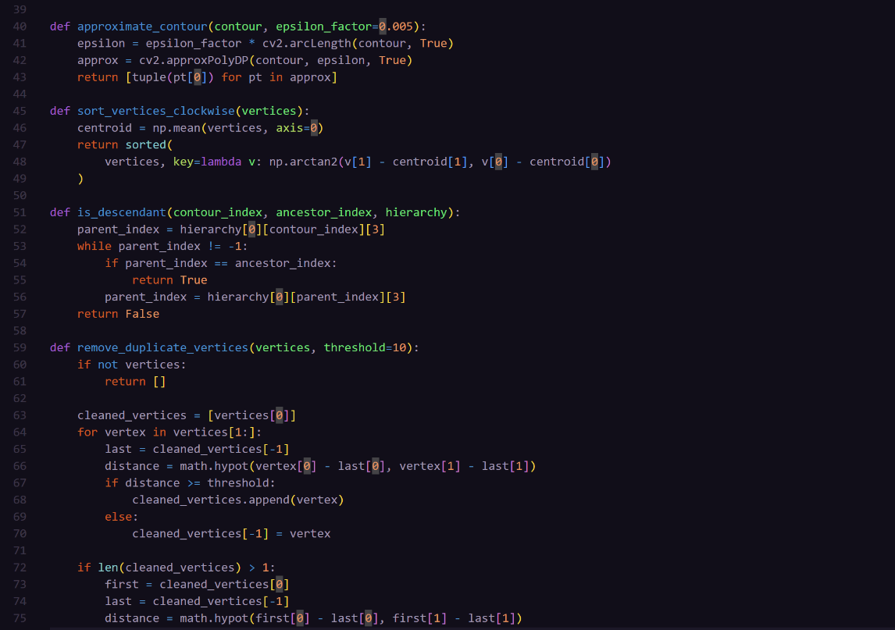

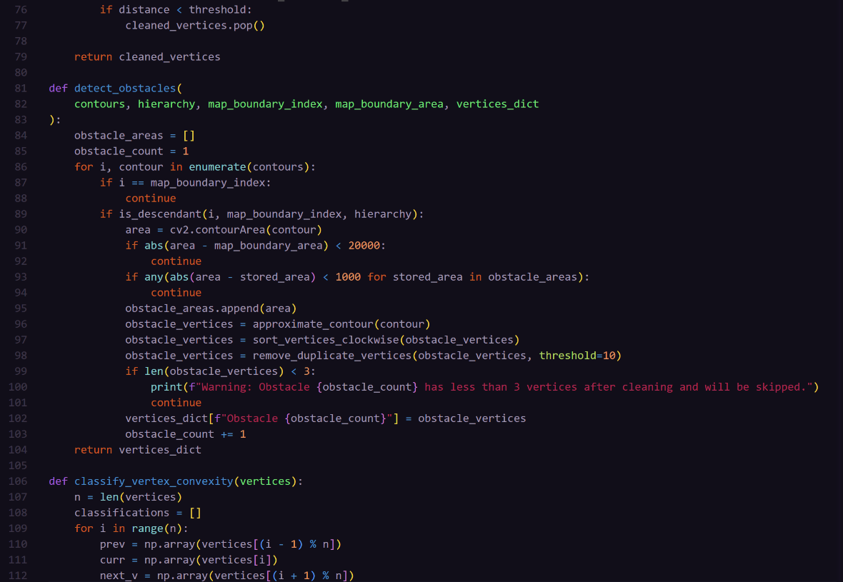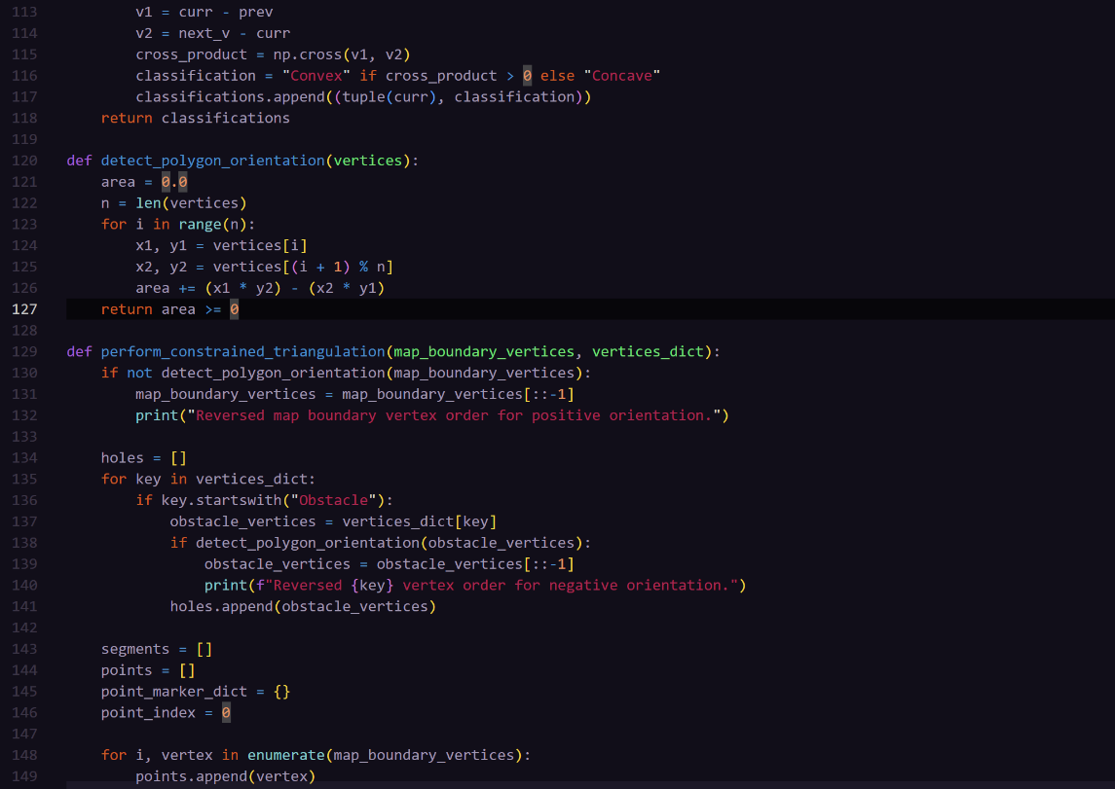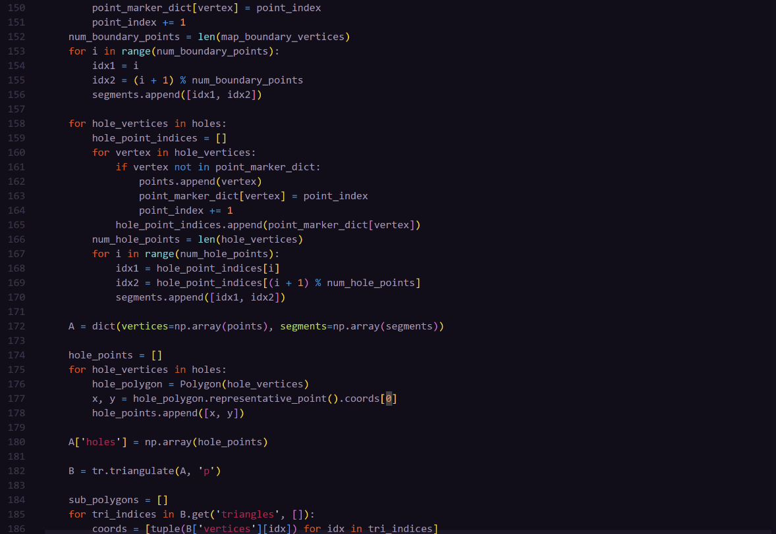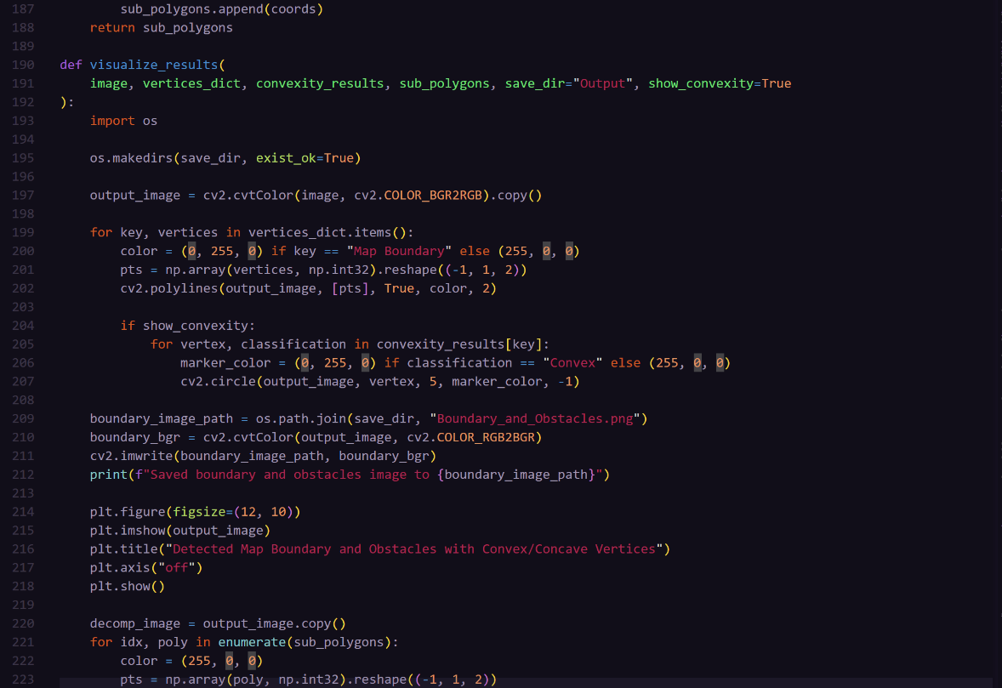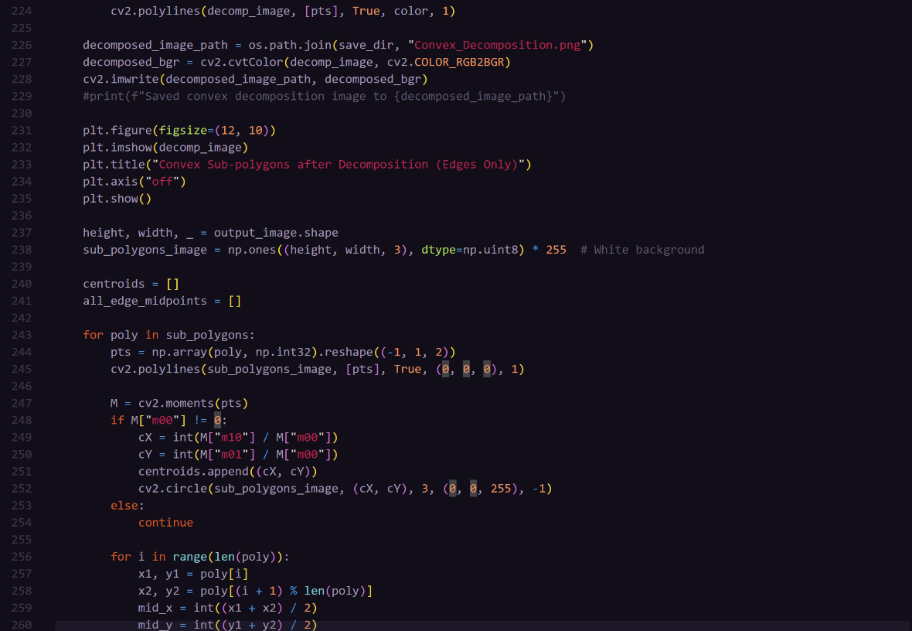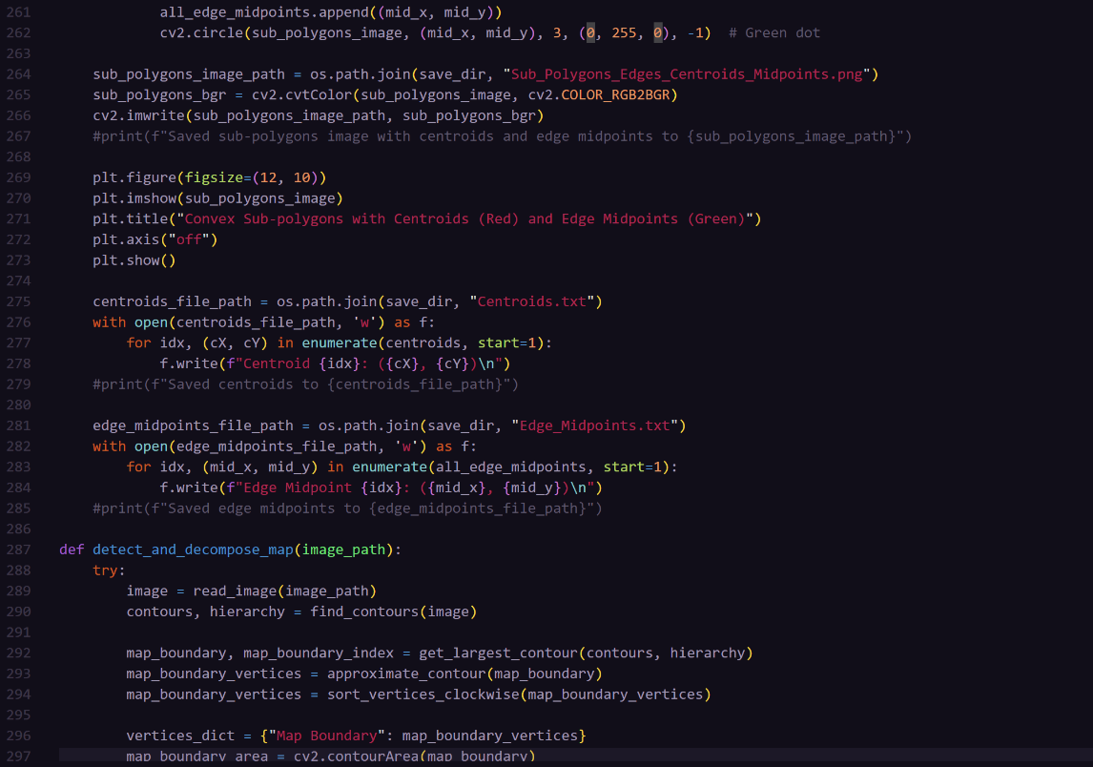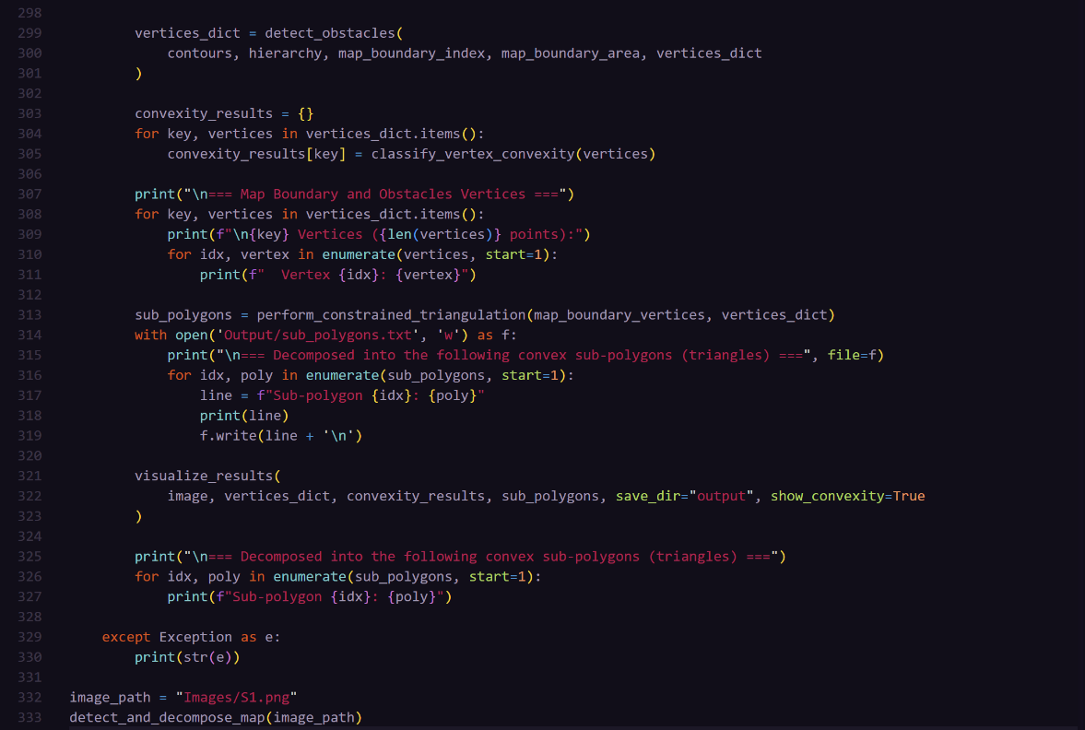

**Optimized A* Algorithm**

**REFERENCES**

[1] Zhaoying L, Ruoling S, Zhao Z. A new path planning method based on sparse A* algorithm with map segmentation. Transactions of the Institute of Measurement and Control. 2022;44(4):916-925. doi:[10.1177/01423312211046410](https://doi.org/10.1177/01423312211046410)